8. PO/Requisition Menu: R. Reports Menu: 1. Purchase Journal

Table of Contents
Purchase Journal 3
Style: Display Style 4
Style: Wide Style 5

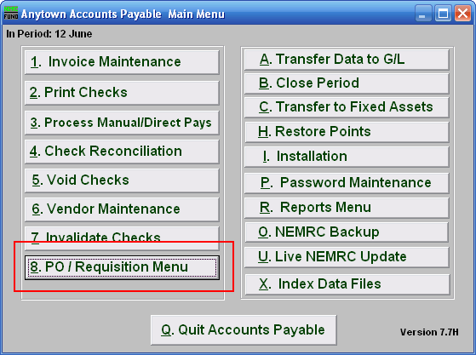
Click on “8. PO / Requisition Menu” from the Main Menu and the following window will appear:

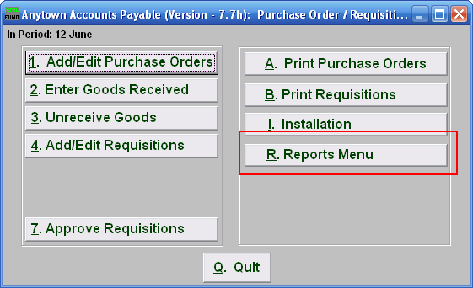
Click on “R. Reports Menu” from the Purchase Order / Requisition Menu and the following window will appear:

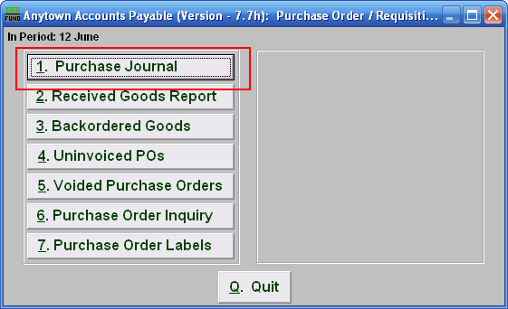
Click on “1. Purchase Journal” from the Purchase Order / Requisition’s Reports Menu and the following window will appear:

Purchase Journal

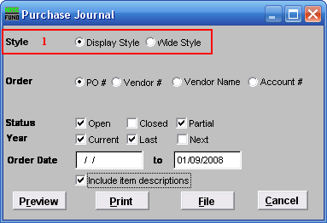
- Style: Click to select which style you want the report to print in. The wide style has more information and options than the display style.

Style: Display Style

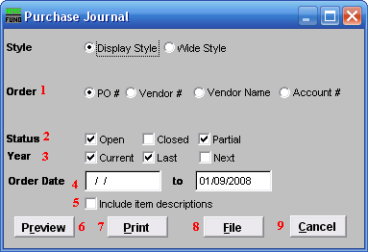

- Order: Select what Order you want the report to be in.

- Status: Select whether you want the report to show Open and/or Closed and/or Partial orders. Check all that apply.

- Year: Select whether you want the report to show Current and/or Last and/or Next year Purchase Orders. Check all that apply.

- Order Date: Type in the Order Date Range you want the report to include. The empty first date field is treated as all orders up to the end date.

- Include item descriptions: Select to include item descriptions, for a more detailed report.

- Preview: Click this button to preview this report. Refer to GENERAL PREVIEW for more information.

- Print: Click this button to print this report. Refer to GENERAL PRINTING for more information.

- File: Click this button to save this report on this computer. Refer to GENERAL FILE for more information.

- Cancel: Click “Cancel” to cancel and return to the previous screen.

Style: Wide Style

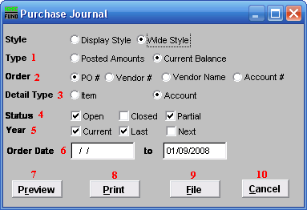
- Type: Select whether you want the report to show Posted Amounts or Current Balance.

- Order: Select what Order you want the report to be in.

- Detail Type: Select whether Items or Accounts are shown in detail in this report.

- Status: Select whether you want the report to show Open and/or Closed and/or Partial orders. Click all that apply.

- Year: Select whether you want the report to show Current and/or Last and/or Next year Purchase Orders. Click all that apply.

- Order Date: Type in the Order Date Range you want the report to include. The empty first date field is treated as all orders up to the end date.

- Preview: Click this button to preview this report. Refer to GENERAL PREVIEW for more information.

- Print: Click this button to print this report. Refer to GENERAL PRINTING for more information.

- File: Click this button to save this report on this computer. Refer to GENERAL FILE for more information.

- Cancel: Click “Cancel” to cancel and return to the previous screen.

